SOFTWARE ENGINEERING - LAB 2
Agile Backlog Creation & Sprint Simulation in Jira
Book Club Reading Challenge & Discussion Portal

- Epics and User Stories

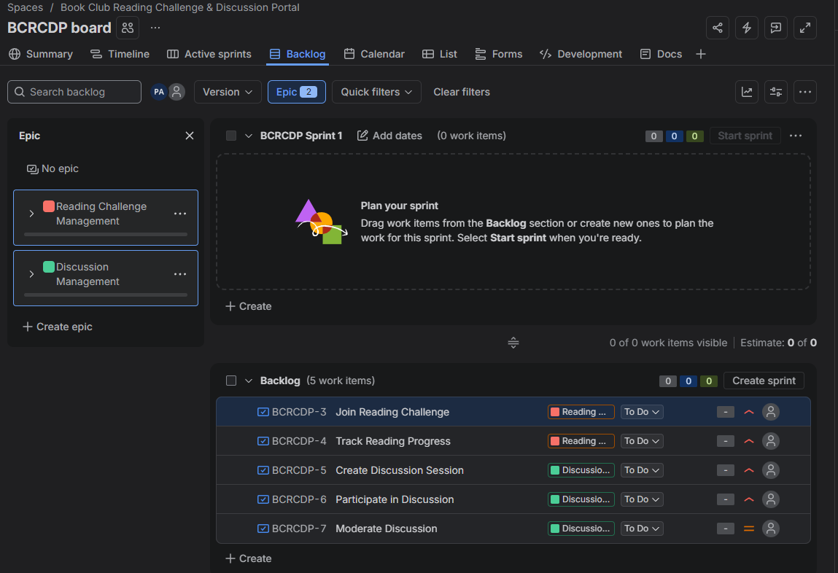

Epic 1: Reading Challenge Management
- Join Reading Challenge
- Track Reading Progress
Epic 2: Discussion Management
- Create Discussion Session
- Participate in Discussion
- Moderate Discussion

- Story Point Assignments

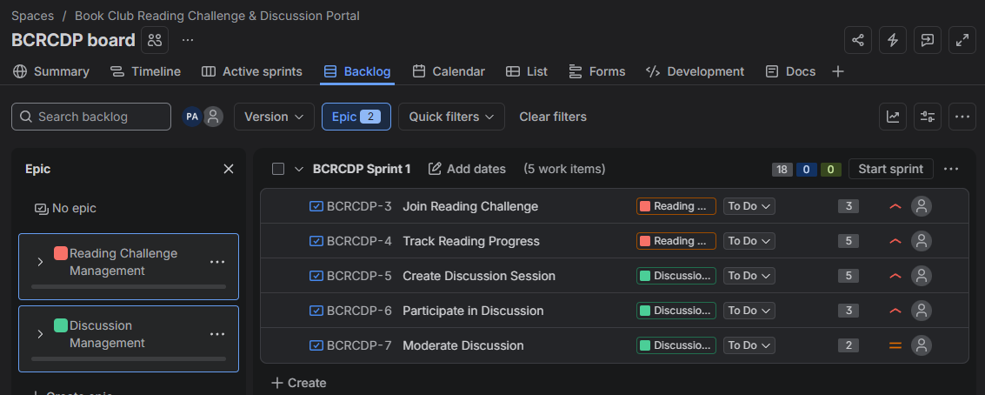

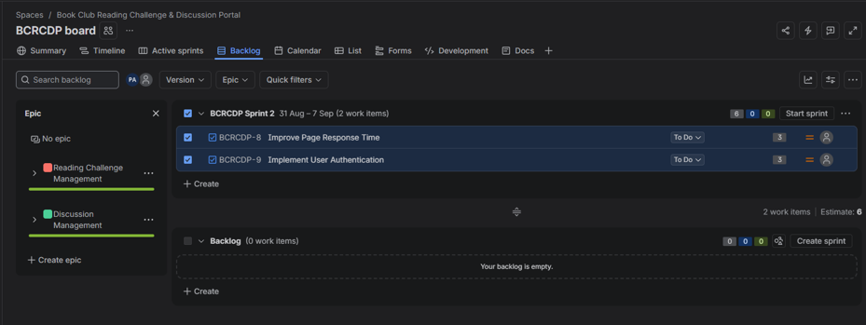

User Story(sprint 1) | Story Points
Join Reading Challenge | 3
Track Reading Progress | 5
Create Discussion Session | 5
Participate in Discussion | 3
Moderate Discussion | 2
Total | 18

- Sprint 1 — Active Sprint

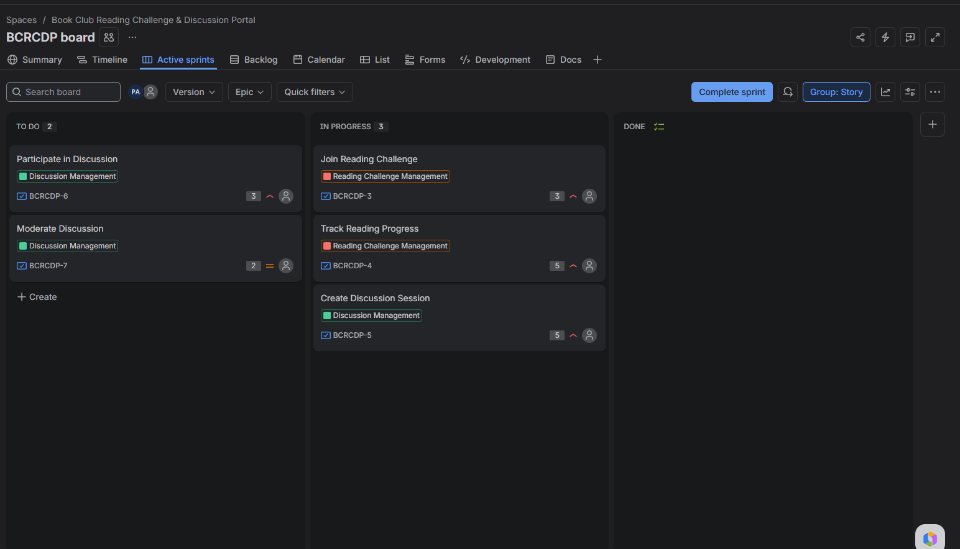
Sprint 1 was simulated by moving the User Stories through To Do, In Progress, and Done.
- Burndown Charts
Figure 1: Sprint 1 Burndown Chart
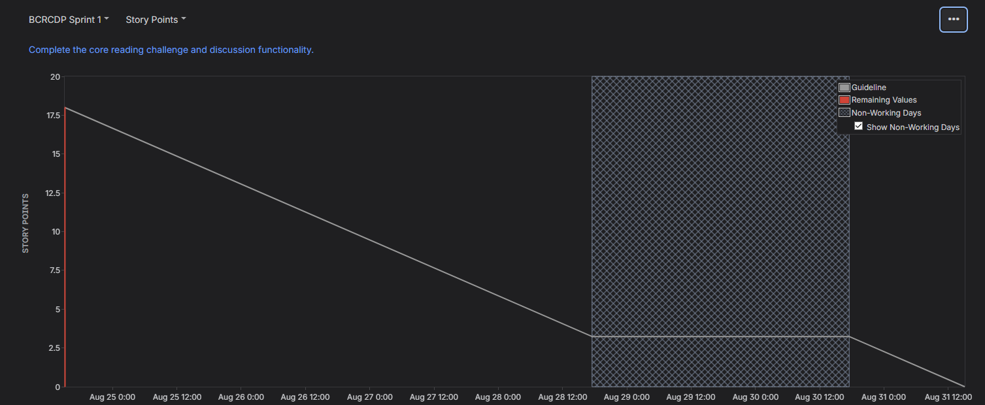
Figure 2: Sprint 2 Burndown Chart
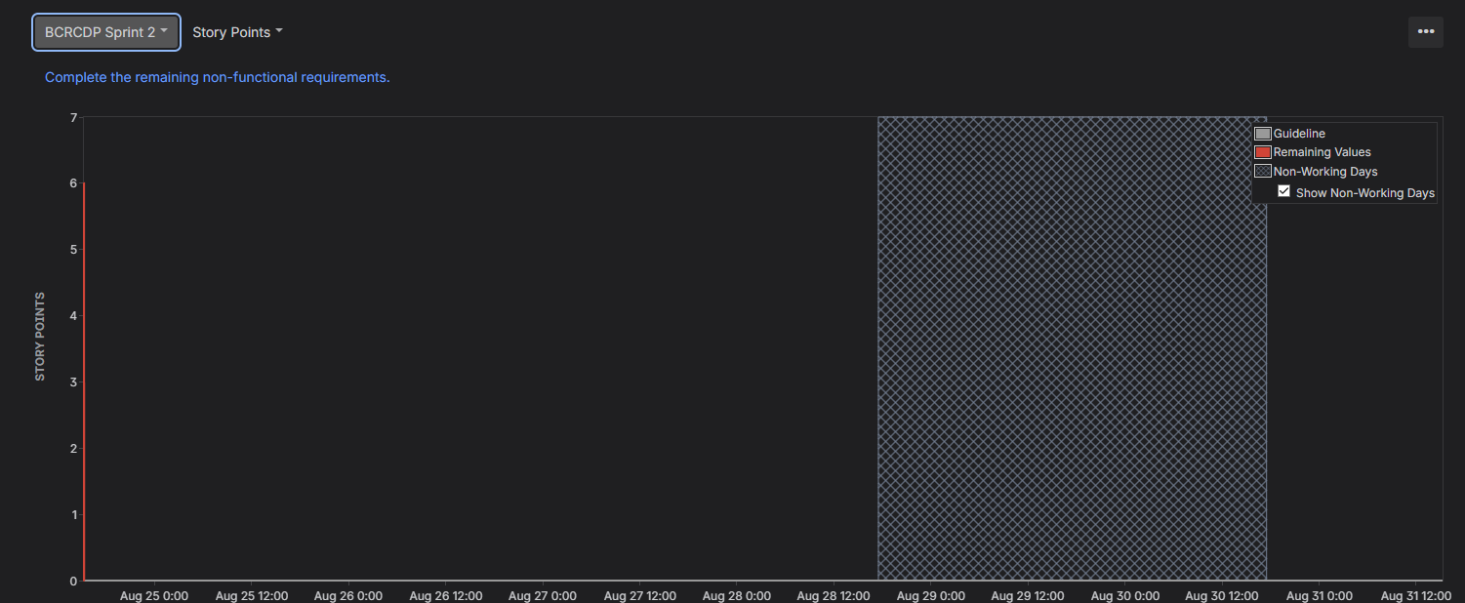
5. Reflection

1. Did your estimations reflect the actual effort?
Yes. The story point estimates provided a reasonable relative measure of effort based on the complexity, effort, and uncertainty associated with each User Story.
2. Was your backlog well-prioritized?
Yes. The core reading challenge and discussion requirements were given higher priority, while discussion moderation was given medium priority. This allowed the most important functionality to be addressed first.
3. How did your simulated sprint align with your plan?
Sprint 1 followed the planned workflow by moving the User Stories from To Do to In Progress and then to Done. Sprint 2 was subsequently used to complete the remaining non-functional requirements.
4. What insights did the burndown chart give about your team's capacity?
The Burndown Chart provided a visual representation of the remaining story points throughout the sprint and helped show the team's progress toward completing the planned work. It can be used to assess whether the amount of work committed to a sprint is appropriate.

